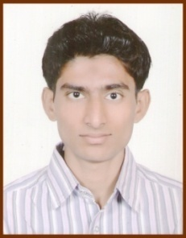**RESUME**

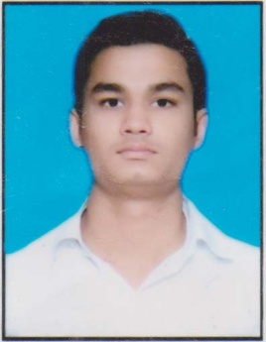

**MD KHURSHEED ALAM**

Contact No. - +91-6260237894

Email Id: [khursheedalam0906@gmail.com](mailto:khursheedalam0906@gmail.com)

Add: House No.-52 Purana Kila Kamla Park

Bhopal-462001

**CAREER OBJECTIVE**

To start and build a carrier in the field of Computer Science Engineering with my discipline and hard work.

**ACADEMIC QUALIFICATION**

**Bachelor of Engineering, Computer Science & Engineering**

University of Technology of Madhya Pradesh

Graduation Date : June 2019

CGPA : 7.66 (HONS)

**PROFESSIONAL SKILLS**

* C Language
* C++ Language
* Proficient in Python

**PROJECT**

* Emotion Based Music Player

**STRENGTH**

* Quick Learner
* Smart Worker
* Flexible by Nature

**PERSONAL DETAILS**

Father’s Name : Lal Mohammad

Address (Permanent) : Vill-Birdipur, Po-Arai Birdipur,

Ps-Simri, Dist-Darbhanga, Bihar-847106

Nationality : Indian

Gender : Male

DOB : 17/04/1997

Marital status : Single

Hobbies : Listening Music, Watching Sci Fi Movies

& Reading books

Language Known : Hindi, English & Urdu

**DECLARATION**

I hereby declare that the information provide above is up-to-date and correct to the best of my knowledge.

**Date: ……../………/……….. Md Khursheed Alam**

**Place : …………………… Signature**